Project Documentation

Frontend Development with React.js

Project Title: CRYPTOVERSE

**Team Member 1: Santhana Laxmi K [TEAM LEADER]**

**(E-mail ID : stu_santhanalaxmi_k@cttewc.edu.in)**

**Team Member 2: Sandhiya M [ASSISTANT TEAM LEADER ]**

**(E-mail ID : stu_sandhiya_m4@cttewc.edu.in)**

**Team Member 3: Kavitha G [TEAM MEMBER]**

**(E-mail ID : stu_kavitha_g@cttewc.edu.in)**

**Team Member 4: Thirusha N [TEAM MEMBER]**

**(E-mail ID : stu_thirusha_n@cttewc.edu.in)**

**1.INTRODUCTION:**

● Cryptoverse is a cutting-edge cryptocurrency tracking and analysis app designed for enthusiasts, investors, and traders. It provides real-time market data, in-depth analytics, and the latest news from the world of blockchain and digital assets. With an intuitive user interface and powerful features, Cryptoverse empowers users to make informed decisions in the fast-paced crypto market.

**2.PROJECT OVERVIEW:**

● A cryptocurrency dashboard with five years of historical price data is a vital tool for investors, traders, and analysts seeking deep market insights. This feature-rich platform enables informed decision-making by offering a comprehensive view of cryptocurrency performance through interactive charts and customizable timeframes.

**Purpose:**

● Users can track price trends, compare assets, and analyze volatility, long-term patterns, and investment risks. Advanced analytical tools, including moving averages, volume trends, and correlation analysis, provide a clearer perspective on market sentiment and external influences.

● Beyond investment optimization, the dashboard serves as an educational resource, helping users understand market cycles, asset correlations, and price-driving factors. Whether for research, portfolio management, or trading strategy development, it equips users with data-driven insights to navigate the evolving crypto landscape confidently.

**Features:**

● **Cryptoverse** is an advanced cryptocurrency dashboard that provides investors with **comprehensive market insights** through five years of historical price data analysis. It enables users to explore cryptocurrency performance over time, supporting data-driven investment decisions.

● With **interactive charts, customizable timeframes, and seamless navigation**, Cryptoverse offers a user-friendly experience for both novice and experienced investors. Users can analyze market fluctuations, compare assets, and assess volatility trends with ease.

● **Cryptoverse serves as an educational resource**, helping users recognize historical patterns, understand external market influences, and refine their investment strategies. Whether for **portfolio management, market research, or trading strategy development**, Cryptoverse equips users with the tools to navigate the evolving cryptocurrency landscape with confidence.

##### SCENARIO BASED QUESTION:

USE CASE: Analyzing Historical Cryptocurrency Data with Cryptoverse

**NAME :** Sarah  
**PROFILE :** Trading enthusiast interested in analyzing historical cryptocurrency data to make informed investment decisions.

1. **Objective**: Sarah aims to identify crypto assets that have shown consistent growth over the past five years to diversify her investment portfolio effectively.
2. **Using Cryptoverse**: Sarah opens the Cryptoverse application on her computer.
3. **Navigation**: She finds the navigation within the website seamless, facilitated by react-router-dom. She easily navigates to the "Cryptocurrencies" page.
4. **Browsing Cryptocurrencies**: Sarah starts browsing through the list of cryptocurrencies available on the platform.
5. **Visual Currency Browsing**: Each cryptocurrency is accompanied by beautiful chart representations of price fluctuations since its creation.
6. **Interactive Charts**: Sarah clicks on the chart of Bitcoin to view detailed historical price data, adjusting the timeframe using react-chartjs-2 and Chart.js.
7. **Price Fluctuation Visualization**: Sarah examines historical price changes and observes Bitcoin's volatility over time.
8. **Search Feature**: She easily finds specific cryptocurrencies such as Bitcoin and Ripple and compares their historical data.
9. **Insights and Decision-Making**: After thorough analysis, Sarah identifies assets that have demonstrated consistent growth and decides to include them in her investment portfolio.
10. **Educational Resource**: Throughout her exploration, Sarah finds the Cryptoverse application valuable for both investment decisions and learning about cryptocurrency trends.
11. **Further Customization and Development**: Impressed by Cryptoverse, Sarah decides to contribute feedback and share the platform with fellow traders.

**Target Audience:**

Cryptoverse is designed to cater to a wide range of users:

● **Investors & Traders** – Individuals looking for historical price trends to make data-driven investment decisions.

● **Crypto Enthusiasts** – People interested in learning about cryptocurrencies and their performance.

● **Market Analysts & Researchers** – Analysts who study historical trends for research purpose.

● **Developers** – Individuals interested in expanding the platform by contributing to open-source development

3.ARCHITECTURE:

**Component Structure:** Project setup and configuration:

**1. Setup React Application:**

• Create a React app in the client folder.

• Install required libraries

• Create required pages and components and add routes.

**2.Design UI components:**

• Create Components.

• Implement layout and styling.

• Add navigation.

**3.Implement frontend logic:**

• Integration with API endpoints.

• Implement data binding.

**State Management:**

● Redux Toolkit is used for scalable global state management, enabling predictable state updates. State is structured into feature-based slices, simplifying management. Redux Thunk handles asynchronous API calls efficiently.

● RapidAPI integrates CoinRanking API to fetch cryptocurrency data, storing it in Redux for direct component access without prop drilling. This approach optimizes data flow and performance.This approach ensures a structured and efficient state management flow, making the application responsive and data-driven.

**Routing:**

● The project utilizes react-router for client-side navigation. Routes are defined using BrowserRouter, with major pages structured within Routes and Route components. Protected routes are implemented using a higher-order component (HOC) that checks authentication status before rendering secured pages.

4.SETUP INSTRUCTIONS:

**Prerequisites:**

Here are the key prerequisites for developing a frontend application using

● Node.js with npm

● React.js

● Git hub

●Visual studio code

● Rapid Api

**Installation :**

● Node.js is a powerful JavaScript runtime environment that allows you to run JavaScript code on the local environment. It provides a scalable and efficient platform for building network applications

● Install Node.js and npm on your development machine, as they are required to run JavaScript on the server-side.

● Download: https://nodejs.org/en/download/

● Installation instructions: https://nodejs.org/en/download/package-manager/

● HTML, CSS, and JavaScript: Basic knowledge of HTML for creating the structure of your app, CSS for styling, and JavaScript for client-side interactivity is essential.

● Version Control: Use Git for version control, enabling collaboration and tracking changes throughout the development process. Platforms like GitHub or Bitbucket can host your repository.

● Git: Download and installation instructions can be found at:

<https://git-scm.com/downloads>

● Development Environment: Choose a code editor or Integrated Development

Environment (IDE) that suits your preferences, such as Visual Studio Code, Sublime Text, or WebStorm.

● Visual Studio Code: Download from <https://code.visualstudio.com/download>

● Sublime Text: Download from <https://www.sublimetext.com/download>

● WebStorm: Download from <https://www.jetbrains.com/webstorm/download>

● Clone the code from github repository:

Follow below steps:

* Git repository: <https://github.com/santhanalaxmi-k/cryptoverse.git>
* Git clone command: git clone
* <https://github.com/santhanalaxmi-k/cryptoverse.git>
* Use this command to clone code into your project folder.

● Install Dependencies:

* Start the Development Server:
* To start the development server, execute the following command:
* npm run dev (vite) the App:
* Open your web browser and navigate to <http://localhost:5173/>
* You should see the Cryptoverse app's homepage, indicating that the
* installation and setup were successful.
* You have successfully installed and set up the application on your local machine.
* You can now proceed with further customization, development, and testing as

needed.

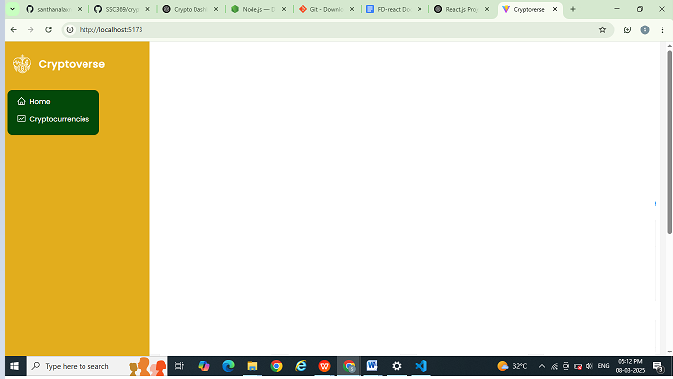

5.FOLDER STRUCTURE:

The organization of the React application, including major folders:

● **app/** - Core application setup and main entry point

● **assets/** - Static assets like images, icons, and styles

● **components/** - Reusable UI components

● **services/** - API calls, data handling logic, and interactions with external services

● **node_modules/** - Installed dependencies and third-party packages

**Utilities:**

● **API Utilities:** Functions that simplify fetching and managing data from CoinRanking API.

● **Custom Hooks:** Hooks designed for handling API requests efficiently, such as useFetchCryptoData, which manages loading states and caching.

● **Error Handling:** Centralized error-handling functions ensure consistent error messages across the app.

● **Data Formatting:** Helpers for formatting currency values, dates, and other data before displaying them in the UI.

These utilities help improve code reusability, maintainability, and efficiency across the React project.

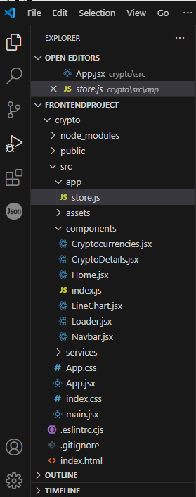

**6.RUNNING THE APPLICATION:**

1. Clone the repository: git clone https://github.com/your-repository.git
2. Navigate to the project directory: cd crypto(File Name)
3. Install dependencies: npm install
4. Run the development server: npm run dev

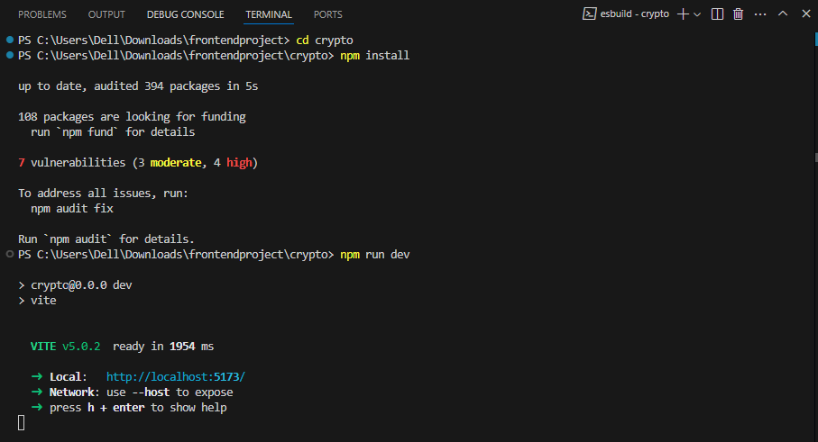

7.COMPONENT DOCUMENTATION:

**Key components:**

* **Cryptocurrencies.jsx:** Displays a list of available cryptocurrencies, fetching data from the CoinRanking API.
* **CryptoDetails.jsx:** Provides detailed information about a selected cryptocurrency, including historical data and market trends.
* **Home.jsx:** Serves as the main landing page, featuring an overview of top cryptocurrencies and market trends.
* **Navbar.jsx:** A navigation component that allows users to switch between different sections of the application.
* **LineChart.jsx:** A reusable chart component that visualizes cryptocurrency trends over time.
* **Loader.jsx:** Displays a loading animation while data is being fetched.
* **index.js:** The entry point of the application, responsible for rendering the root component and setting up routing.

**Reusable Components:**

* **LineChart.jsx:** Used across multiple pages to provide consistent data visualization.
* **Loader.jsx:** A simple loading spinner used across the application for better user experience while fetching data.
* **Navbar.jsx:** Provides a consistent navigation experience across different pages.

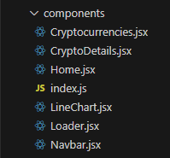

**8.STATE MANAGEMENT:**

**Global State:** Global state is managed using Redux Toolkit. Data from the CoinRanking API, fetched via RapidAPI, is stored in a Redux slice. The application uses Redux Thunk for asynchronous operations, ensuring efficient data retrieval. The Redux store centralizes the state, making it accessible across components without prop drilling.

**Local State:** Local state is handled using the useState hook within individual components. It manages temporary UI states like form inputs, search filters, and modals. In some cases, useReducer is used for more complex state logic, such as handling user interactions in detailed cryptocurrency views.

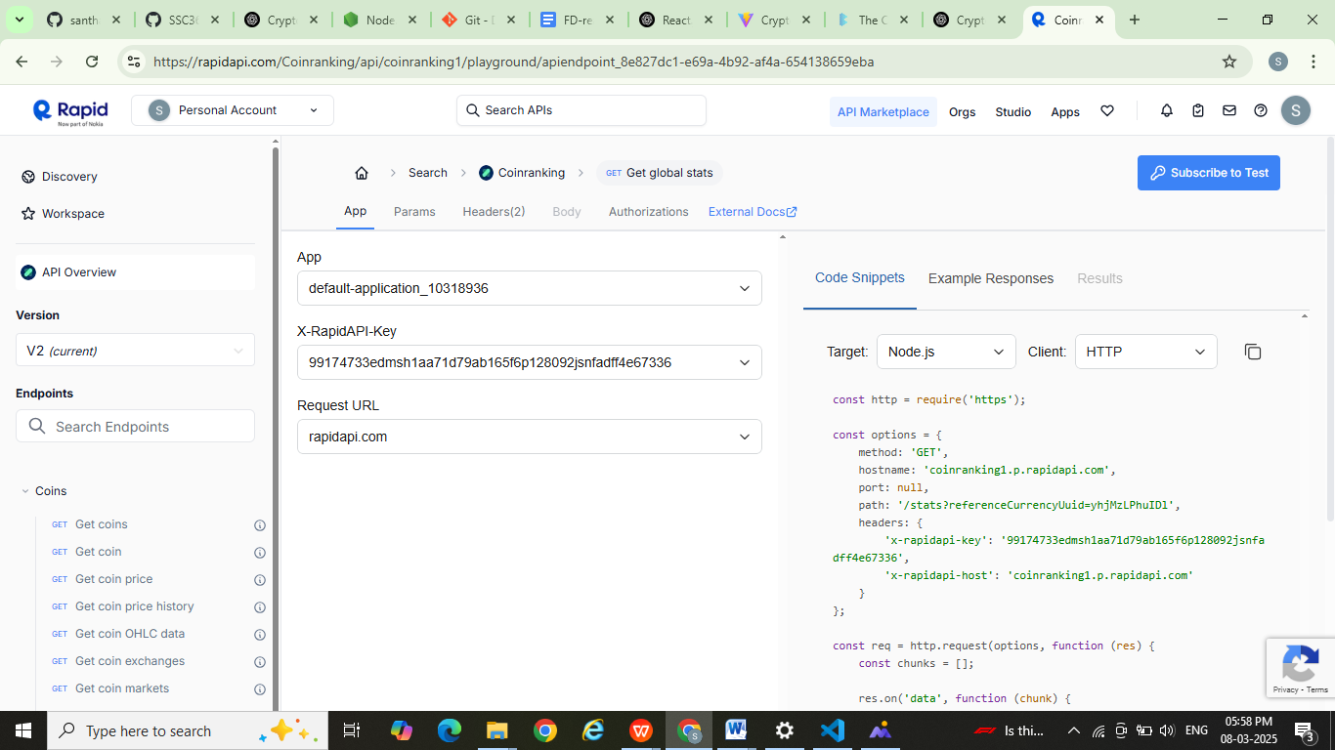



**9.USER INTERFACE:**

Provide screenshots or GIFs showcasing different UI features, including:

* Landing page
* Authentication screens
* Dashboard or main interface
* Forms and input validation feedback

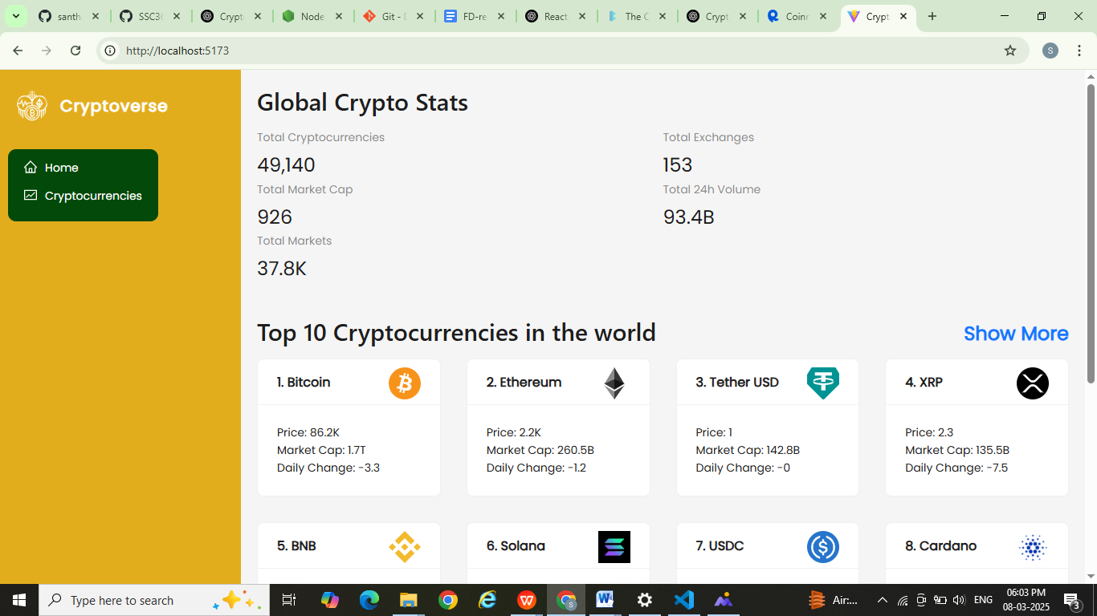

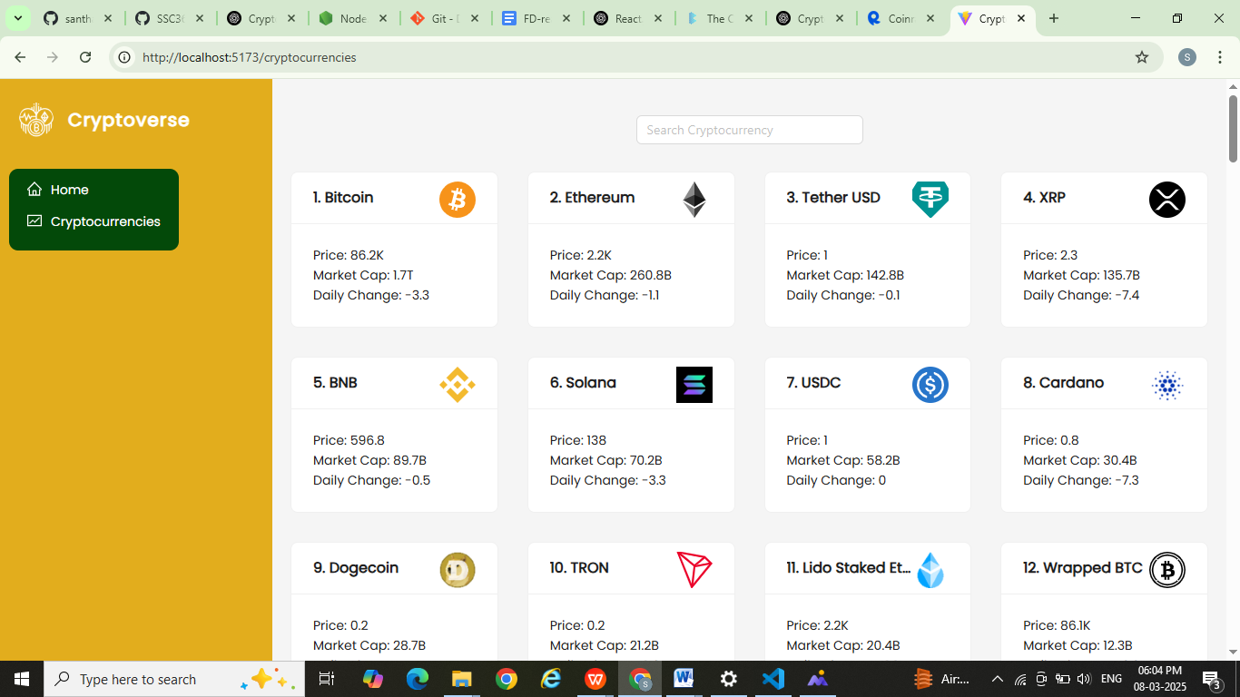

**10.STYLING:**

**CSS Frameworks/Libraries:**The project utilizes plain CSS for styling, with a structured approach using a global stylesheet. The styles are organized into reusable classes to maintain consistency across components. Media queries are implemented for responsive design, ensuring a seamless user experience on different screen sizes.

**Theming:** The application supports multiple themes, including dark mode. Users can toggle between themes through a UI control, such as a button or switch in the settings or navigation bar. The theme state is managed using React's useState or global state (e.g., Redux) and stored in local storage to persist user preferences across sessions. The styling dynamically updates by applying different CSS variables or classes based on the selected theme.

11.TESTING:

**Testing Strategy:** The testing approach for this project includes unit tests, integration tests, and end-to-end testing to ensure code reliability and application stability. Unit tests focus on individual components and functions using Jest and React Testing Library, verifying that each component behaves as expected. Integration tests check interactions between multiple components and Redux state management, ensuring seamless data flow. End-to-end testing is performed using Cypress, simulating real user interactions to validate overall application behavior. Code coverage tools are used to track test effectiveness and maintain high-quality standards.

**Code Coverage:** Test coverage tools, such as Jest's coverage reporting and Istanbul, help ensure the reliability of the application by identifying untested code paths, measuring the extent of test coverage, and highlighting potential gaps in testing. They provide detailed reports on which parts of the codebase are covered by tests, enabling developers to focus on improving test completeness and maintaining high-quality standards. This ultimately helps prevent bugs and ensures consistent application behavior across different scenarios.

**12.SCREENSHOTS OR DEMO:**

13.KNOWN ISSUES:

Yes faced Issues like occasional API request failures due to rate limits, slow rendering of complex data visualizations, and inconsistent theme persistence across sessions. Users can mitigate these issues by implementing retry logic for API calls, optimizing rendering performance, and ensuring proper state storage for theme preferences.

14.FUTURE ENHANCEMENTS:

Outline potential future features or improvements, such as:

* Adding animations and micro-interactions for a more engaging user experience
* Implementing a Progressive Web App (PWA) version for offline support and better performance
* Enhancing accessibility by improving keyboard navigation, screen reader support, and color contrast
* Optimizing performance through lazy loading, code splitting, and efficient state management
* Expanding the application with additional features, such as multi-language support and advanced data visualization